**MAVC Pigeon Clocking System**

**Introduction**

Nowadays Pigeon Racing is one of the popular sports not even in the Philippines but in the whole world.

Pigeon racing is the sport of releasing specially trained [racing pigeons](http://en.wikipedia.org/wiki/Racing_pigeon), which then return to their homes over a carefully measured distance. The time it takes the animal to cover the specified distance is measured and the bird's rate of travel is calculated and compared with all of the other pigeons in the race to determine which animal returned at the highest speed.

Pigeon racing requires a specific breed of pigeon bred for the sport, the "Racing Homer". Competing pigeons are specially trained and conditioned for races that vary in distance for approximately to 100 to 1000 km.

The winner of a pigeon race is the bird with the highest [velocity](http://en.wikipedia.org/wiki/Velocity), measured in ypm or mpm; this calculation demands that the distance be divided into yards, then divide the yards by the number of minutes it took the bird to return. Since races can often be won and lost by seconds, many different timing and measuring devices have been developed. The traditional timing method involves rubber rings being placed into a specially designed clock, whereas a newer development uses [RFID](http://en.wikipedia.org/wiki/RFID) tags to record arrival time.

The most popular timing method in the Philippines is using of Sticker that put in the bird's ring, then when the pigeon arrived from the release point the member or the racer will get the sticker to view the hidden number , using the sms technology the member or the racer will send the code seen in the sticker.

In the Philippines there is already provider(s) that hosted this type of pigeon racing clocking method. Since Pigeon Racing is became popular, It will also increased the number of racer or member that participate to the Pigeon Race, then it will cause of some delay or clogging in the SMS Receiver specially when it also served as sender.

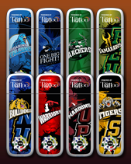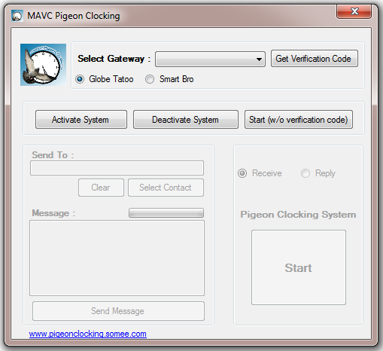 MAVC Pigeon Clocking is pigeon clocking system that also used the same technology. The only different is MAVC Pigeon Clocking is use two stick broadband (globe tattoo or smart bro). This two stick broadband will serve as Sender and Receiver, In this case the SMS Message clogging will prevent.

**Requirements**

1. 2 stick broadband (Receiver and Sender ) with sim card

2. Internet ( Race Result Posting)

3. SMS Pigeon Clocking System (SMS Program)

4.Pigeon Clocking System Management (Data Entry)

**Description**

MAVC Pigeon Clocking System use the unlimited all network promo of Globe or Smart Telecom. This program used regular sim card like we use in our mobile phone. Since we are using a regular number , during the race member can also register for unlimited all network text, so that they can text without any load deducted.

**Is this system is Hack Proof?**

The answer is yes. Since this system is window application and the server is under the club premises, no unauthorized person can access the system.

**System Preview**

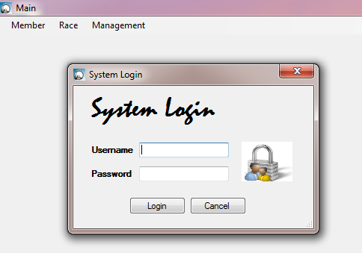System Login

Member Main Menu

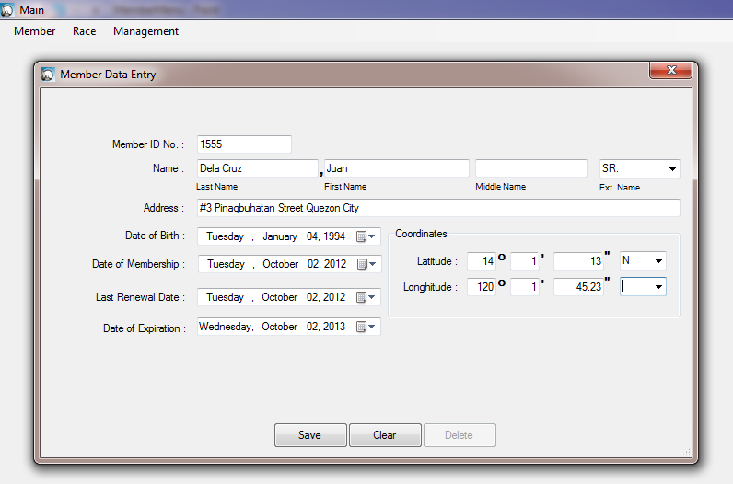 Member Data Entry

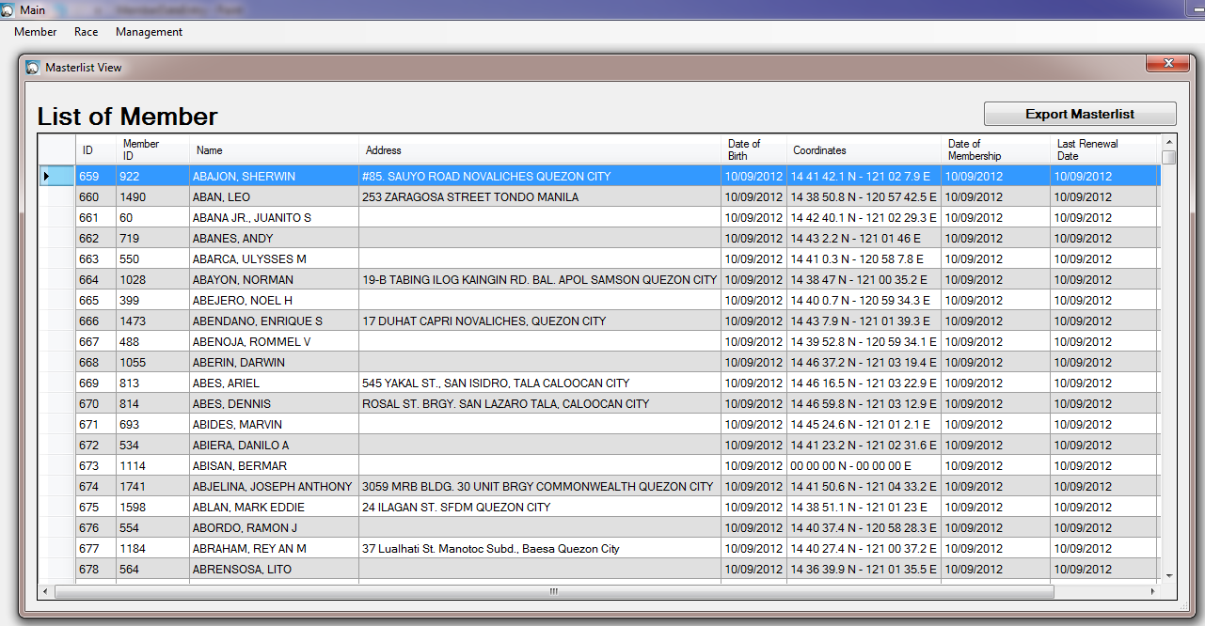Member Master list (can export in excel)

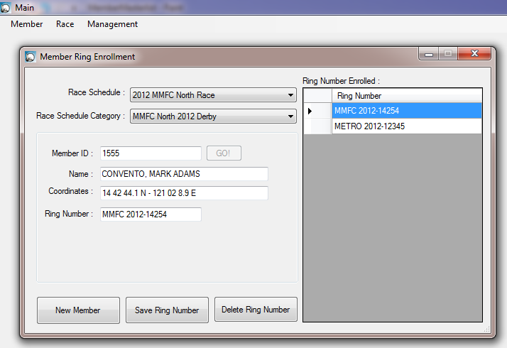Member Ring Management

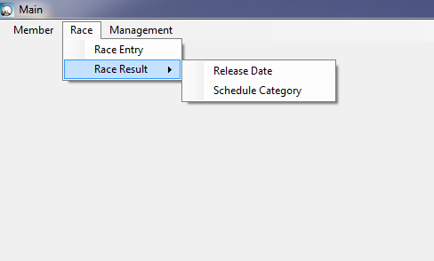Race Main Menu

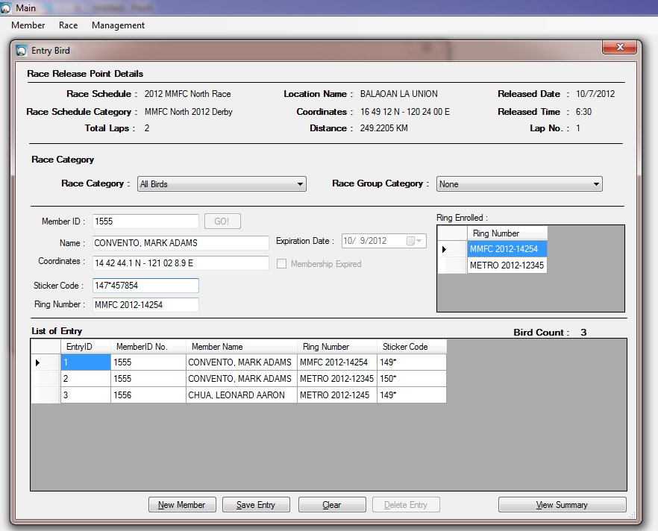Race Bird Entry

Race Result

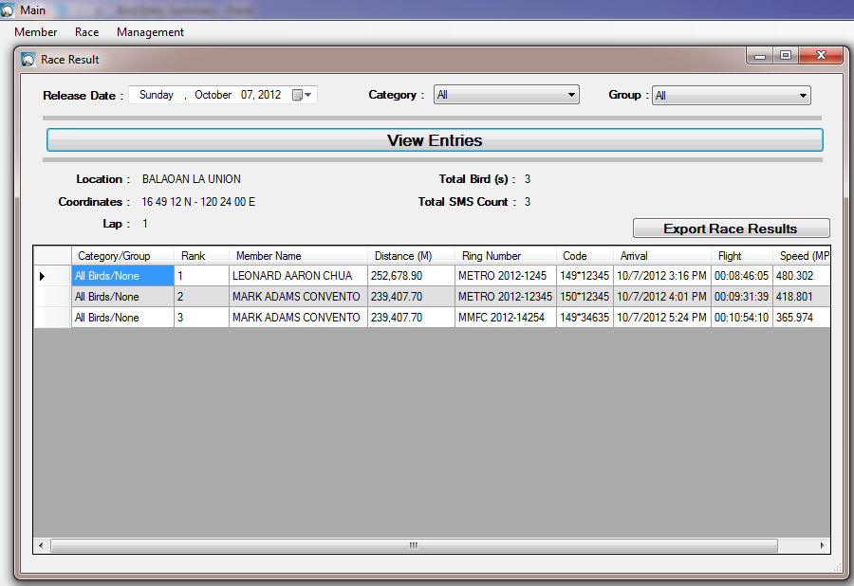Race Result per Date

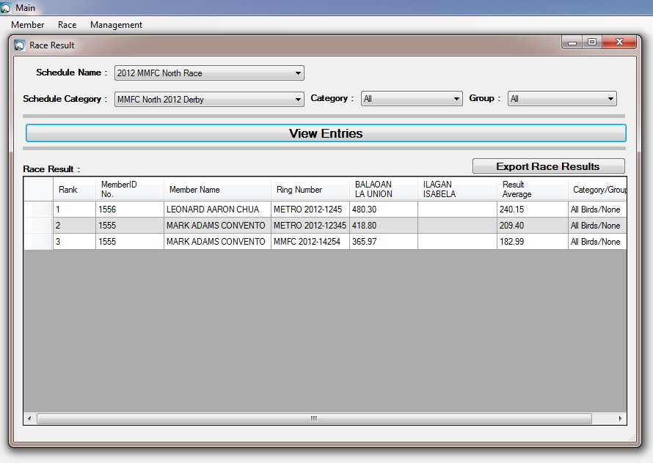Race Result per Category (Over All Result)

To view the Race Result website : www.pigeonclocking.somee.com

For those interested please contact

Mark Adams V. Convento

Mobile No. : 09173540062

Email Address :cmarkadams@yahoo.com